AZURE MONITORING

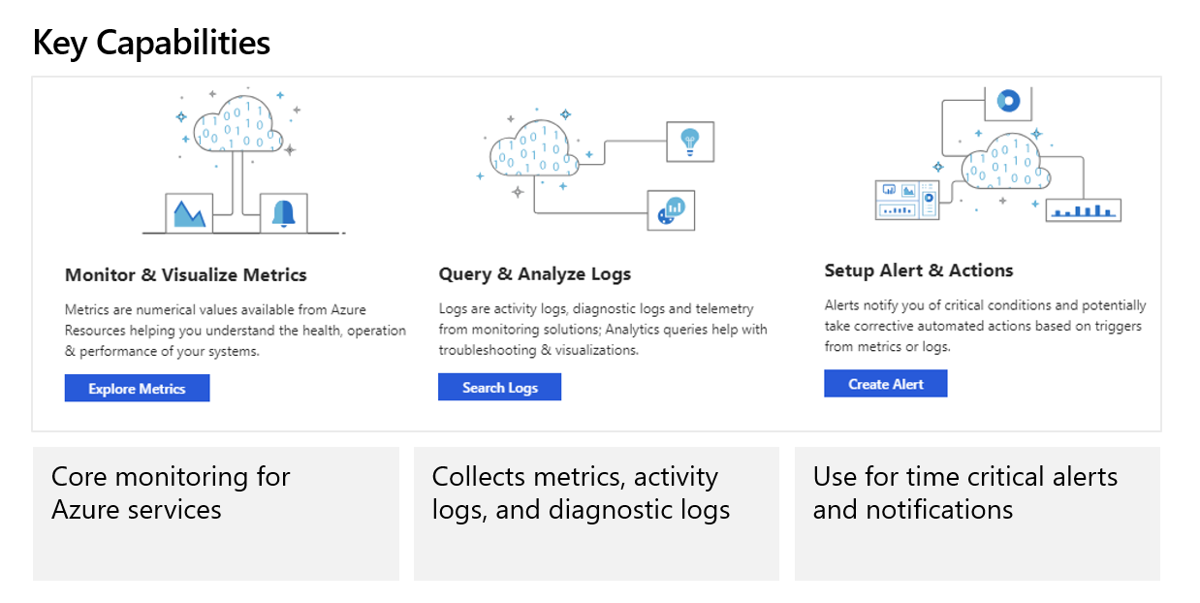
Azure Monitor helps you maximize the availability and performance of your applications and services. It delivers a comprehensive solution for collecting, analyzing, and acting on telemetry from your cloud and on-premises environments. This information helps you understand how your applications are performing and proactively identify issues affecting them and the resources they depend on.
Just a few examples of what you can do with Azure Monitor include:
- Detect and diagnose issues across applications and dependencies with Application Insights.
- Correlate infrastructure issues with VM insights and Container insights.
- Drill into your monitoring data with Log Analytics for troubleshooting and deep diagnostics.
- Support operations at scale with smart alerts and automated actions.
- Create visualizations with Azure dashboards and workbooks.
- Collect data from monitored resources using Azure Monitor Metrics.

Overview
The following diagram gives a high-level view of Azure Monitor. At the center of the diagram are the data stores for metrics and logs, which are the two fundamental types of data used by Azure Monitor. On the left are the sources of monitoring data that populate these data stores. On the right are the different functions that Azure Monitor performs with this collected data. This includes such actions as analysis, alerting, and streaming to external systems.
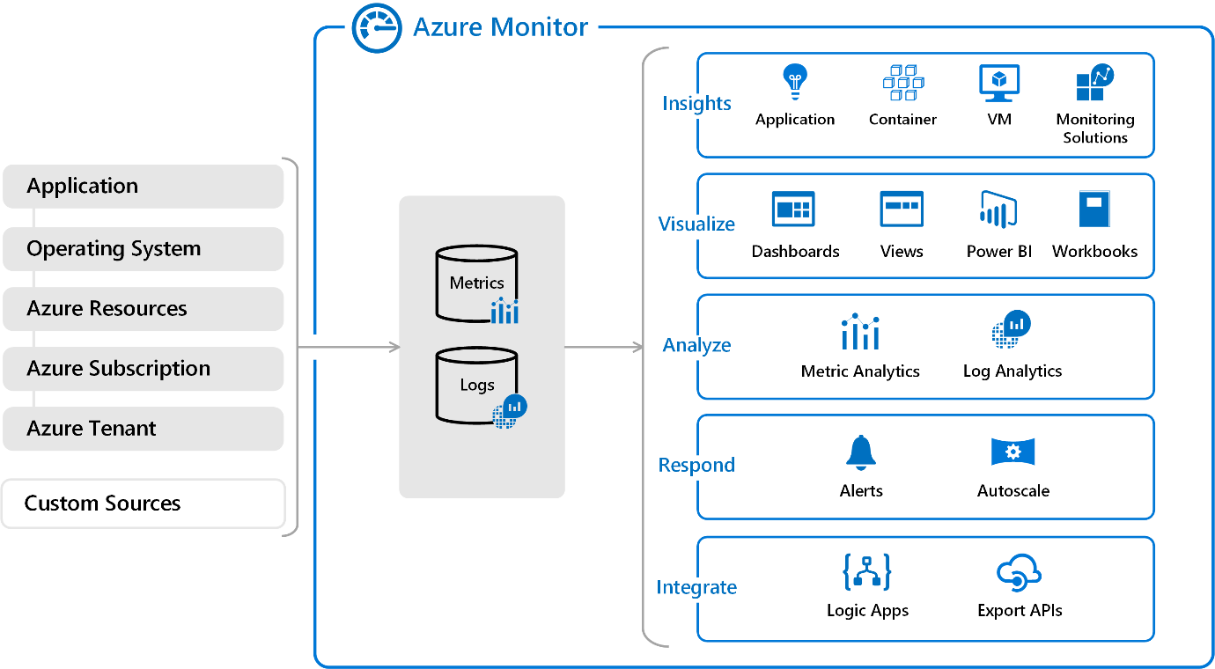

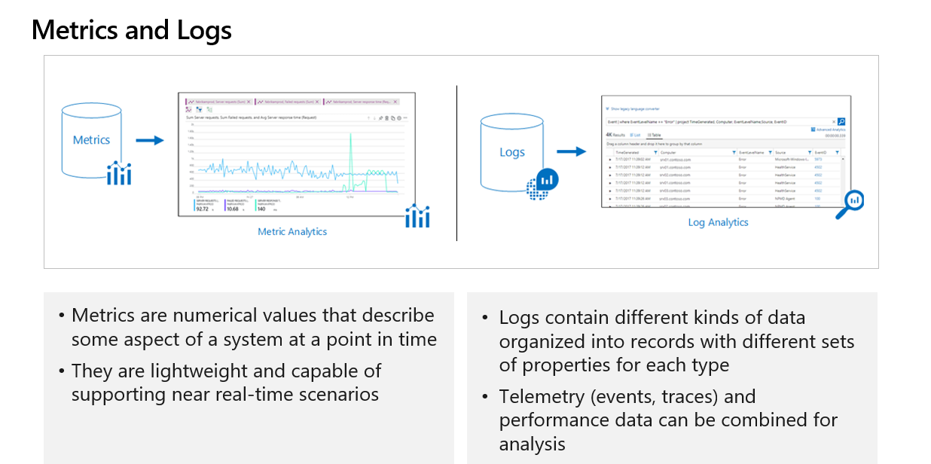

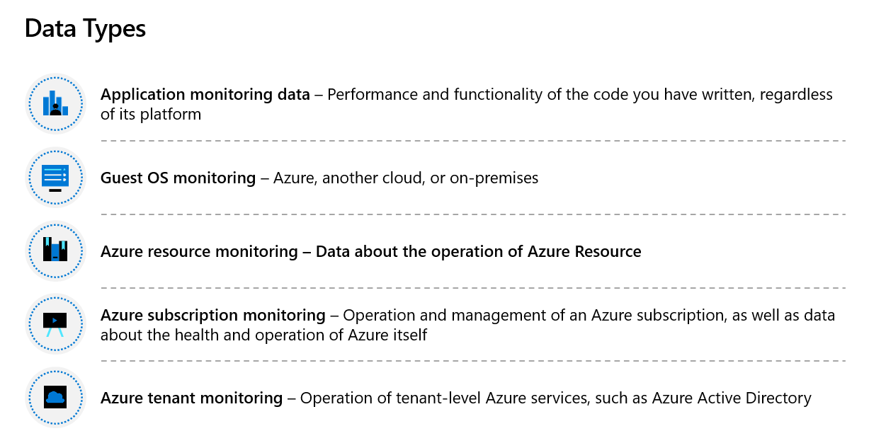

Azure Activity Logs:
Through activity logs, you can determine:
- what operations were taken on the resources in your subscription
- who started the operation
- when the operation occurred
- the status of the operation
- the values of other properties that might help you research the operation
The activity log contains all write operations (PUT, POST, DELETE) for your resources. It doesn't include read operations (GET). For a list of resource actions, see Azure resource provider operations. You can use the activity logs to find an error when troubleshooting or to monitor how a user in your organization modified a resource.
Activity logs are kept for 90 days. You can query for any range of dates, as long as the starting date isn't more than 90 days in the past.
You can retrieve information from the activity logs through the portal, PowerShell, Azure CLI, Insights REST API, or Insights .NET Library.

AZURE ALERTS:

What are alerts in Microsoft Azure?
Alerts proactively notify you when issues are found with your infrastructure or application using your monitoring data in Azure Monitor. They allow you to identify and address issues before the users of your system notice them.

Overview
The diagram below represents the flow of alerts.
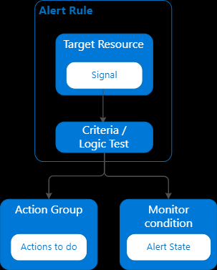

Alert rules are separated from alerts and the actions taken when an alert fires. The alert rule captures the target and criteria for alerting. The alert rule can be in an enabled or a disabled state. Alerts only fire when enabled.
The following are key attributes of an alert rule:
Target Resource - Defines the scope and signals available for alerting. A target can be any Azure resource. Example targets:
- Virtual machines.
- Storage accounts.
- Log Analytics workspace.
- Application Insights.
For certain resources (like virtual machines), you can specify multiple resources as the target of the alert rule.
Signal - Emitted by the target resource. Signals can be of the following types: metric, activity log, Application Insights, and log.
Criteria - A combination of signal and logic applied on a target resource. Examples:
- Percentage CPU > 70%
- Server Response Time > 4 ms
- Result count of a log query > 100
Alert Name - A specific name for the alert rule configured by the user.
Alert Description - A description for the alert rule configured by the user.
Severity - The severity of the alert after the criteria specified in the alert rule is met. Severity can range from 0 to 4.
- Sev 0 = Critical
- Sev 1 = Error
- Sev 2 = Warning
- Sev 3 = Informational
- Sev 4 = Verbose
Action - A specific action taken when the alert is fired. For more information, see Action Groups.

What you can alert on
You can alert on metrics and logs, as described in monitoring data sources. Signals include but aren't limited to:
- Metric values
- Log search queries
- Activity log events
- Health of the underlying Azure platform
- Tests for website availability

Manage alerts
You can set the state of an alert to specify where it is in the resolution process. When the criteria specified in the alert rule is met, an alert is created or fired, and it has a status of New. You can change the status when you acknowledge an alert and when you close it. All state changes are stored in the history of the alert.
The following alert states are supported.
MANAGE ALERTS
State | Description
New | The issue has been detected and hasn't yet been reviewed.
Acknowledged | An administrator has reviewed the alert and started working on it.
Closed | The issue has been resolved. After an alert has been closed, you can reopen it by changing it to another state.
Alert state is different and independent of the monitor condition. Alert state is set by the user. Monitor condition is set by the system. When an alert fires, the alert's monitor condition is set to 'fired', and when the underlying condition that caused the alert to fire clears, the monitor condition is set to 'resolved'.
The alert state isn't changed until the user changes it. Learn how to change the state of your alerts and smart groups.

Azure Action Groups:
Action Groups within Azure are a group of notification preferences and/or actions which are used by both Azure Monitor and service alerts. They can be defined in various ways depending on the environment you are working on, whether one action group is used for all alerts or action groups are split into different alerting scenarios. I will detail this further in this blog.
Each Action Group has the four requirements:
- Action Group Name – The action group name must be unique to the Resource Group it is going to be added to, I prefer to have the action group unique per subscription
- Short Name – The action groups short name, will be included in each email or SMS received
- Subscription – The subscription to which the action group will be added to
- Resource Group –The resource group that the action group will be added to

Action..
Moving on, we now need to the define the action(s) for the Action Group, there are six action types available:-
- Email/SMS/Push/Voice:- Ability to send email, SMS or push notification or a voice call
- Azure Function:- Run a function app
- Logic App:- Run a Logic App
- Webhook:- Deploy a web hook
- ITSM:- Integrate with IT Service Management
- Automation Runbook:- Run an automation runback
When an email action is configured, they can come from these three email Microsoft email addresses
- azure-noreply@microsoft.com
- azureemail-noreply@microsoft.com
- alerts-noreply@mail.windowsazure.com

Action Group Limitations and restrictions
- Email – No more than 100 emails per hour
- SMS – No more than 1 SMS every 5 minutes
- Voice – No more than 1 voice call every 5 minutes
- Azure App Push – You may have up to 10 Azure app actions in an Action Group
- ITSM – You may have up to 10 ITSM actions in an Action Group ITSM Action requires an ITSM Connection
- Logic App – You may have up to 10 Logic App actions in an Action Group
- Azure Function – The function keys for Function Apps configured as actions are read through the Functions API, which currently requires v2 function
- Automation Runbook – Up to 10 Runbook actions in an Action Group
- Action Groups – 2000 action groups per subscription
- Webhook – Up to 10 Webhook actions in an Action Group

AZURE LOG ANALYTICSS:
Follow my class recordings as well as Example which I have delivered in the class to practise.
Refer link on log analytics:
Log Analytics tutorial - Azure Monitor | Microsoft Docs
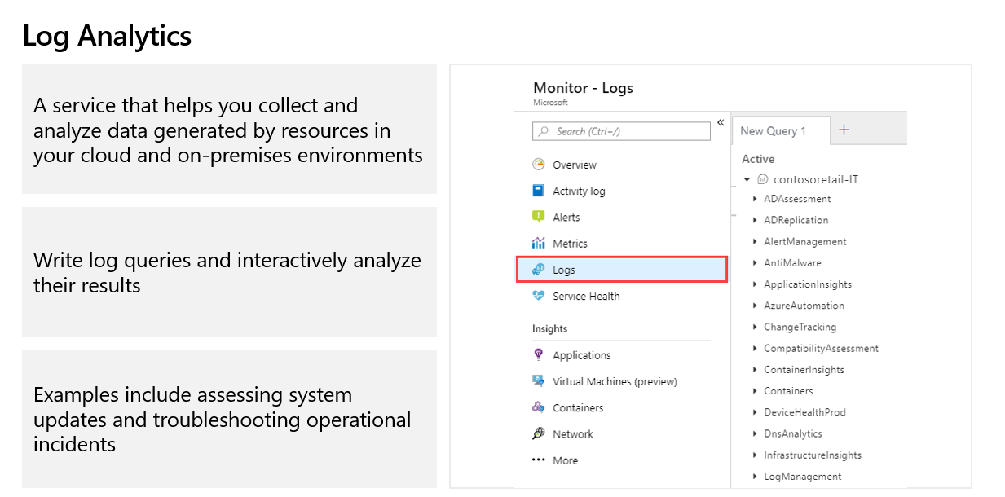

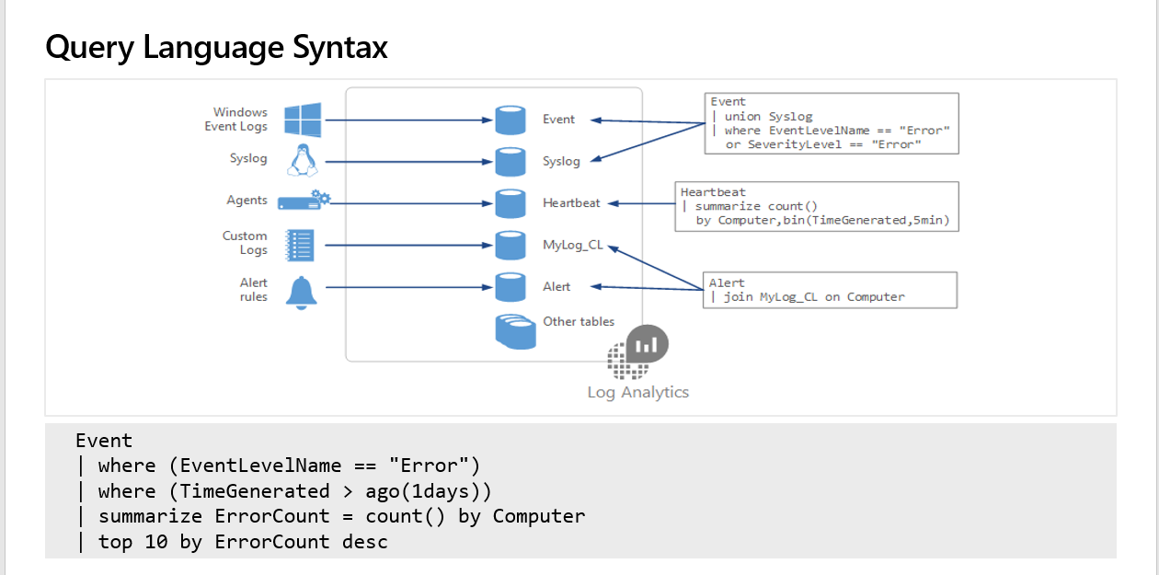

NETWORK WATCHER:
Follow my class recordings as well as Example which I have delivered in the class to practise. It is best use case for Network Wather so not including any notes for Network Watcher.

